Shared Server installation manual

In order to run a website that is available to anyone as long as there is an internet connection, the website has to be uploaded onto a shared server capable of hosting PHP and its Laravel framework. There is multiple server hosting websites with a demanding membership fee in order to be able to use their services, but for the purpose of this project, the hosting server used is heroku. Heroku enables users to upload their website onto their server, with an extension to their domain name (example: https://**schedule-heroku**.herokuapp.com/). There is also other PHP hosting servers that enables the user to have their own domain name, such as https://www.fortrabbit.com/. However, it is important to keep in mind that on top of the server fee, the user is asked the domain name.

Step 1: Heroku membership

If a user wishes to try Heroku's services, it is possible to sign up for free. A free membership includes 512MB of RAM for 1 website, all managed by one unique user. For the sake of the scheduler software, this is enough, since the software is about 30MB. If interested, other offers are listed under the **Pricing** section on the navigation bar. However, for now, the user should click **SIGN UP FOR FREE.**

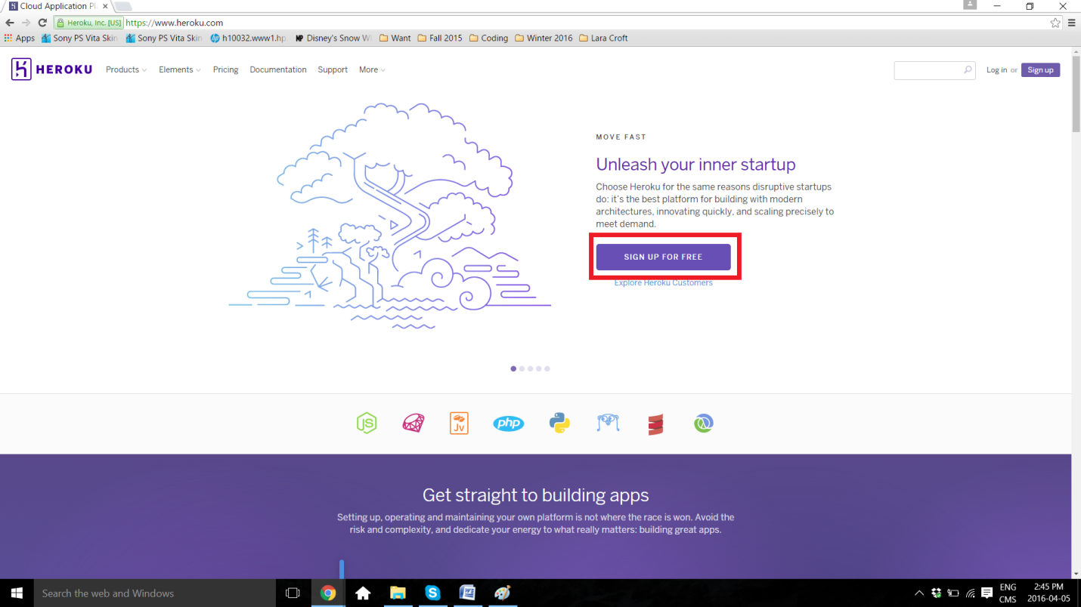

The user is then required to register by filling in the necessary information, such as **first name**, **last name**, **email**, **company name**, and **select a language**. Afterwards, an email is sent for confirmation, and once confirmed, the password can be set.

Step 2: Installing the Heroku Toolbelt

It is necessary to install Heroku Toolbelt in order to have access to their repository github.

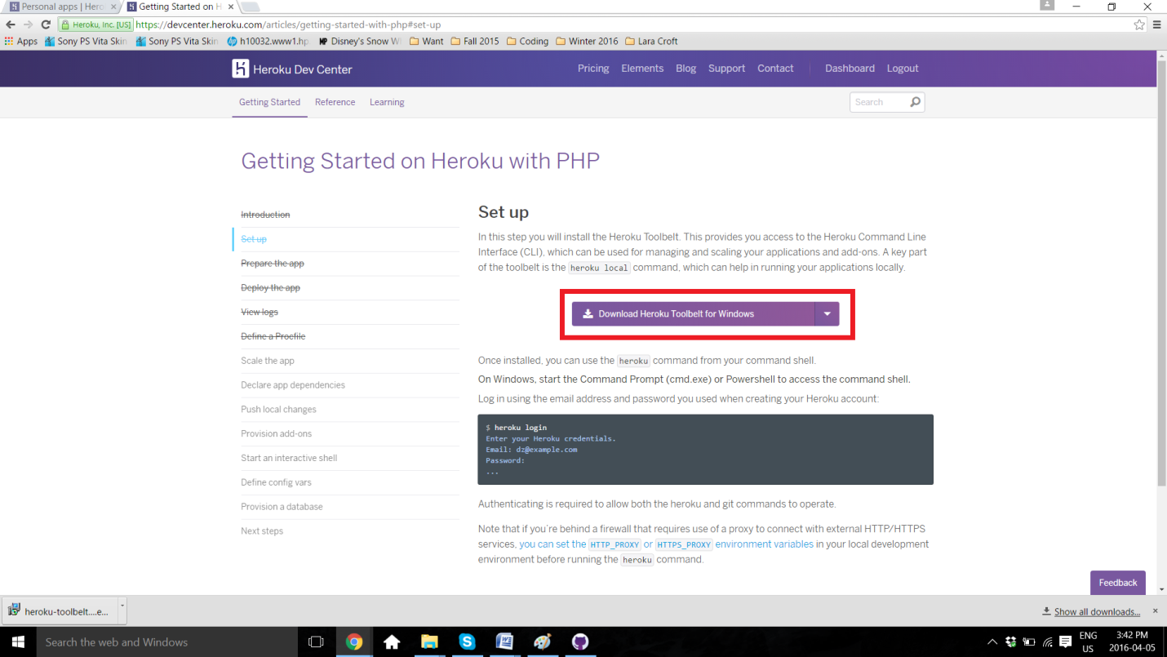

Clcik on the